Exercise 2.1 (Extinction coefficients of semiconductors)
Semiconductors are used in optoelectronic devices due to their advantageous optical properties. In the figures below the optical constants $n$ and $k$ are given as a function of wavelength.
- For each example below, calculate the necessary film thickness to absorb 90% of the incident radiation intensity at 700 nm (reflectance and interference can be neglected).
- Calculate the reflective loss of incident radiation due to reflection using :
$$R=\frac{{\left(n_{rel}-1\right)}^{2}+{k_{rel}}^{2}}{{(n_{rel}+1)}^{2}+{k_{rel}}^{2}}$$
- Discuss the optical constants of the different materials, with a view to their use in photovoltaics.
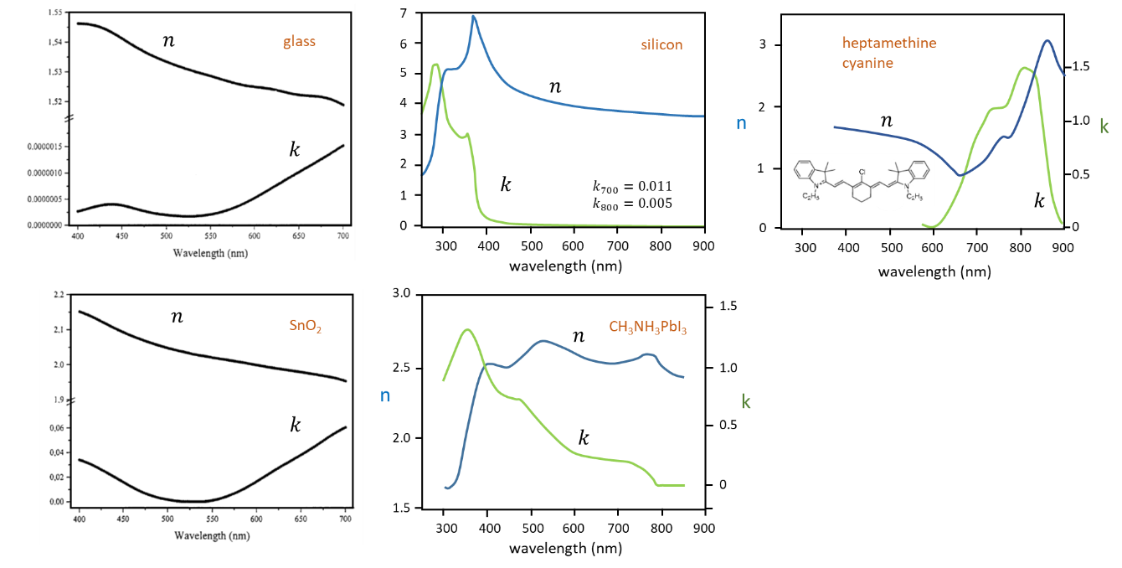
Exercise 2.2 (total reflection, penetration depth)
In a Fourier Transform Infrared Spectrometer in ATR mode, IR light is coupled into a diamond window. At the diamond/air interface, total reflection occurs. If a fine powder is pressed onto the diamond window, the infrared spectrum of the powder can be measured.
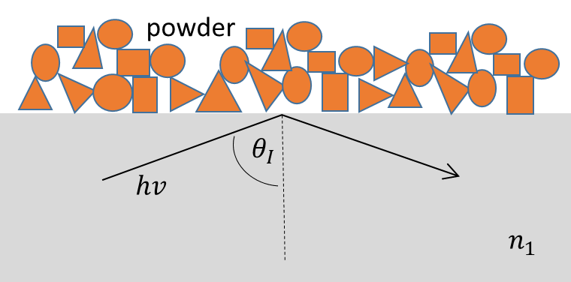
- Explain the working principle of this method. How can the sensitivity be increased?
- Determine the minimum angle $θ_{I}$to be used, assuming a diamond/air interface.
- Calculate the penetration depth of the evanescent wave induced by total reflection for a typical IR wavenumber (1500 cm⁻¹) and a typical incidence angle of 45°.
- This method can also be used for liquids. How does the penetration depth depend on the refractive index of the liquid? Use a typical incidence angle of 45°.

